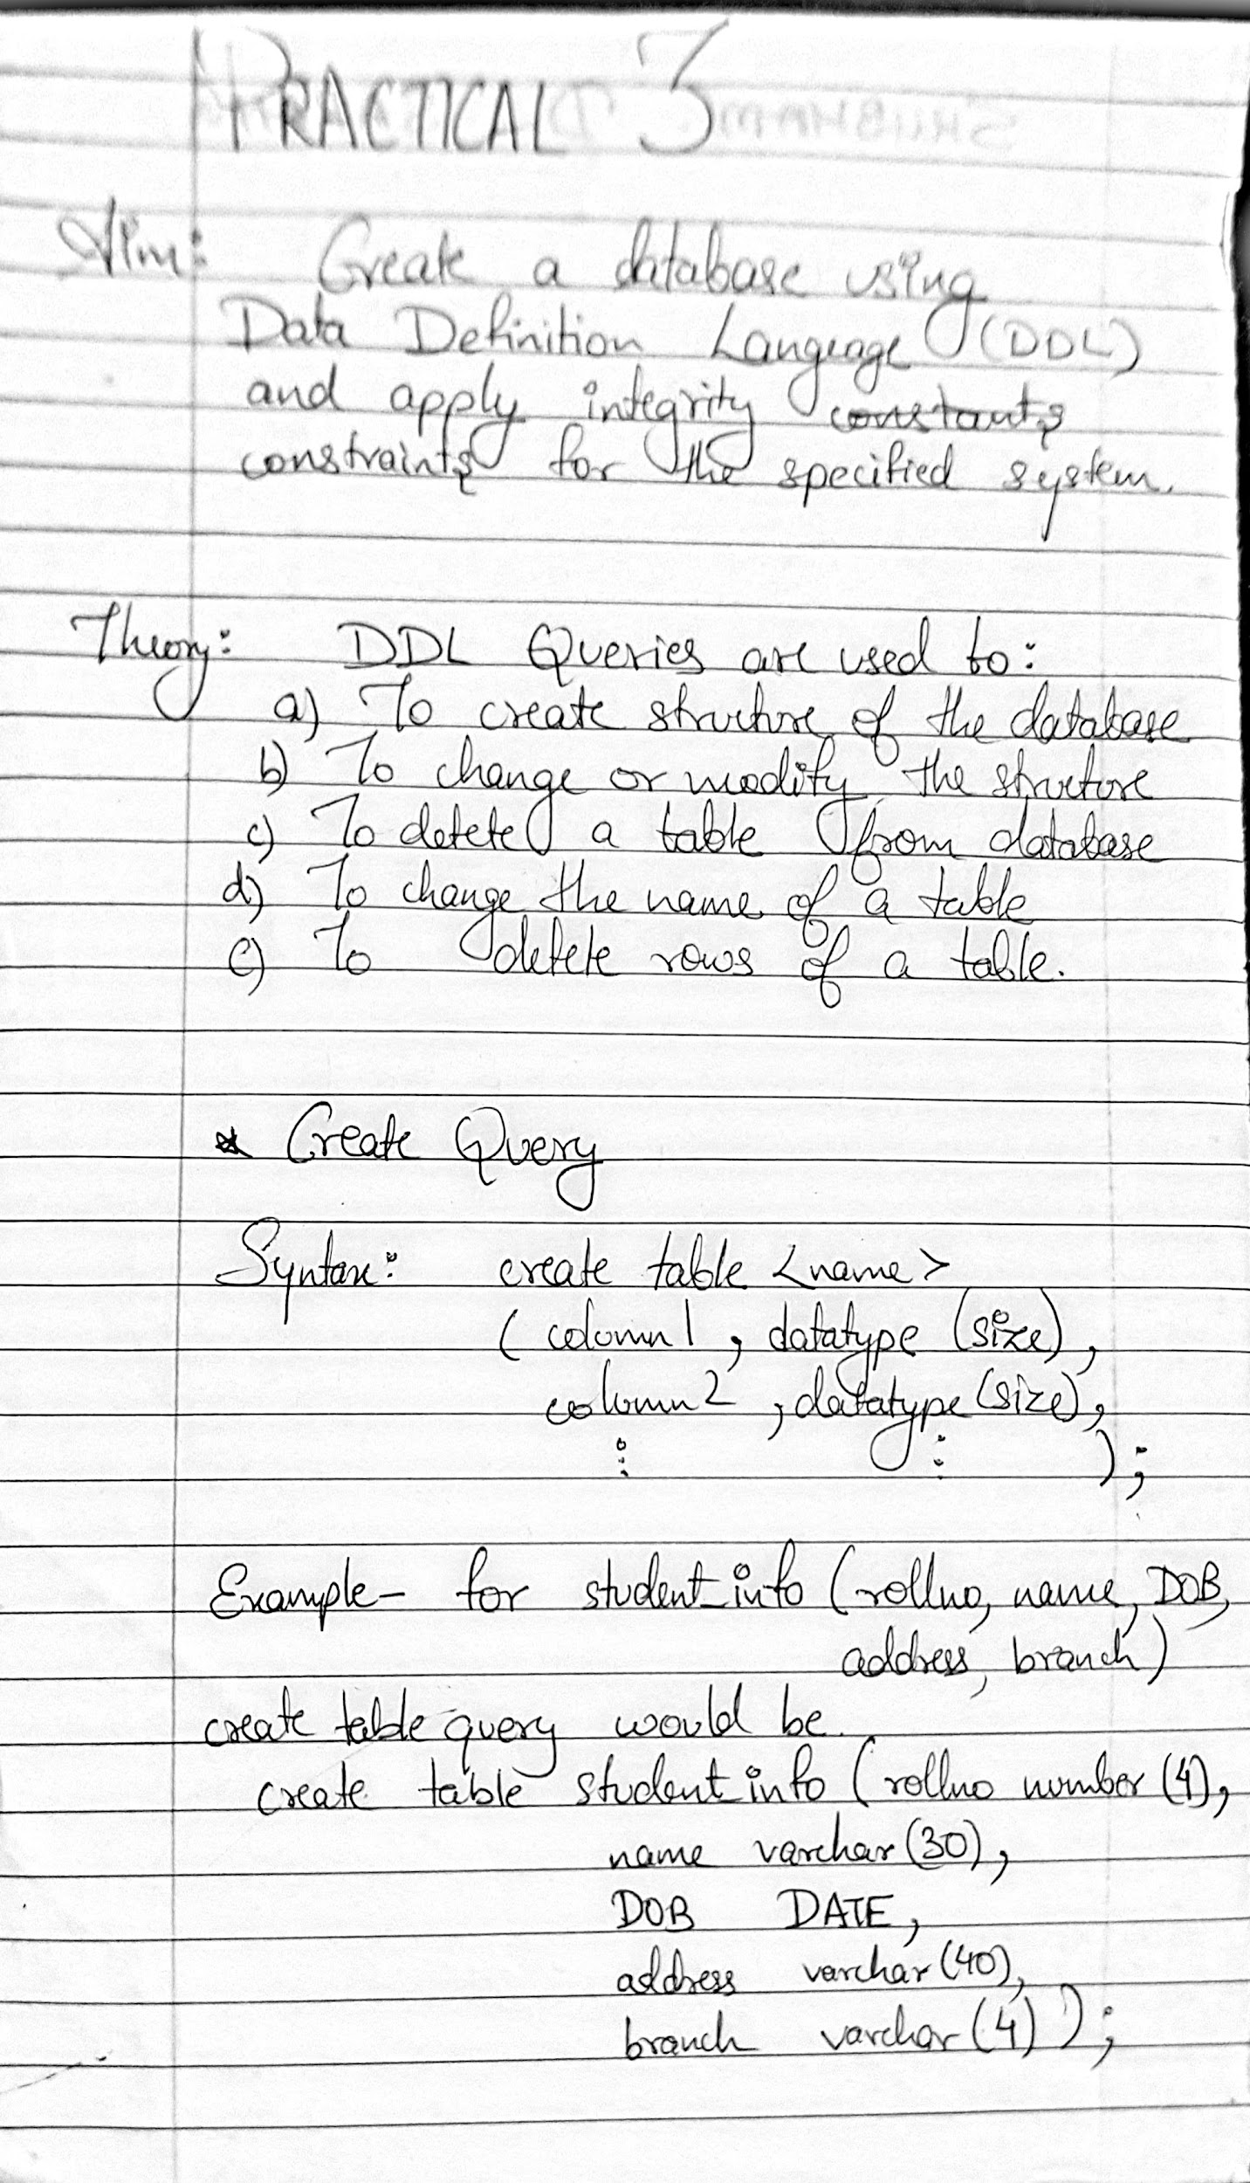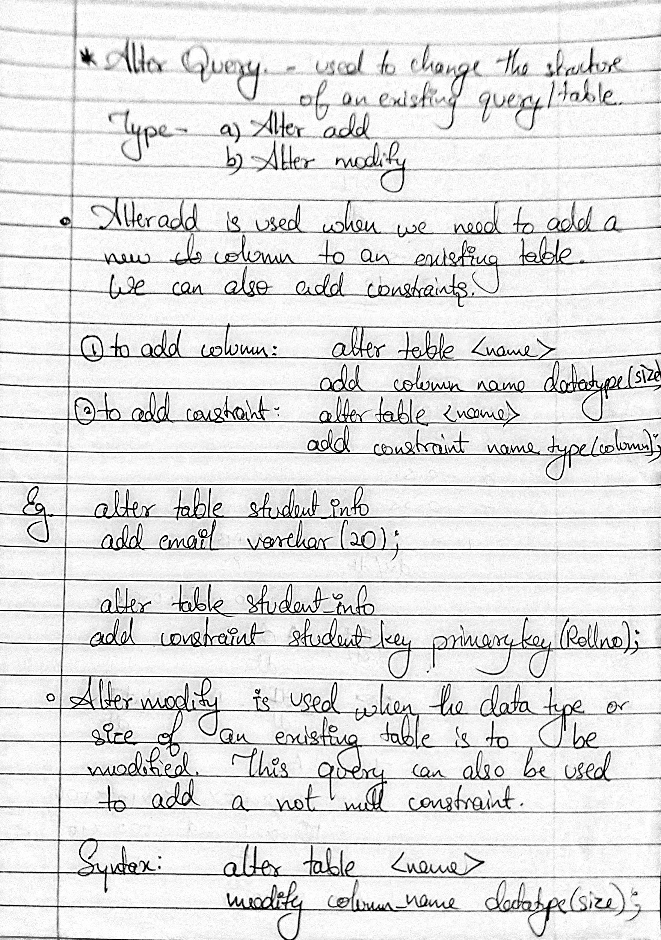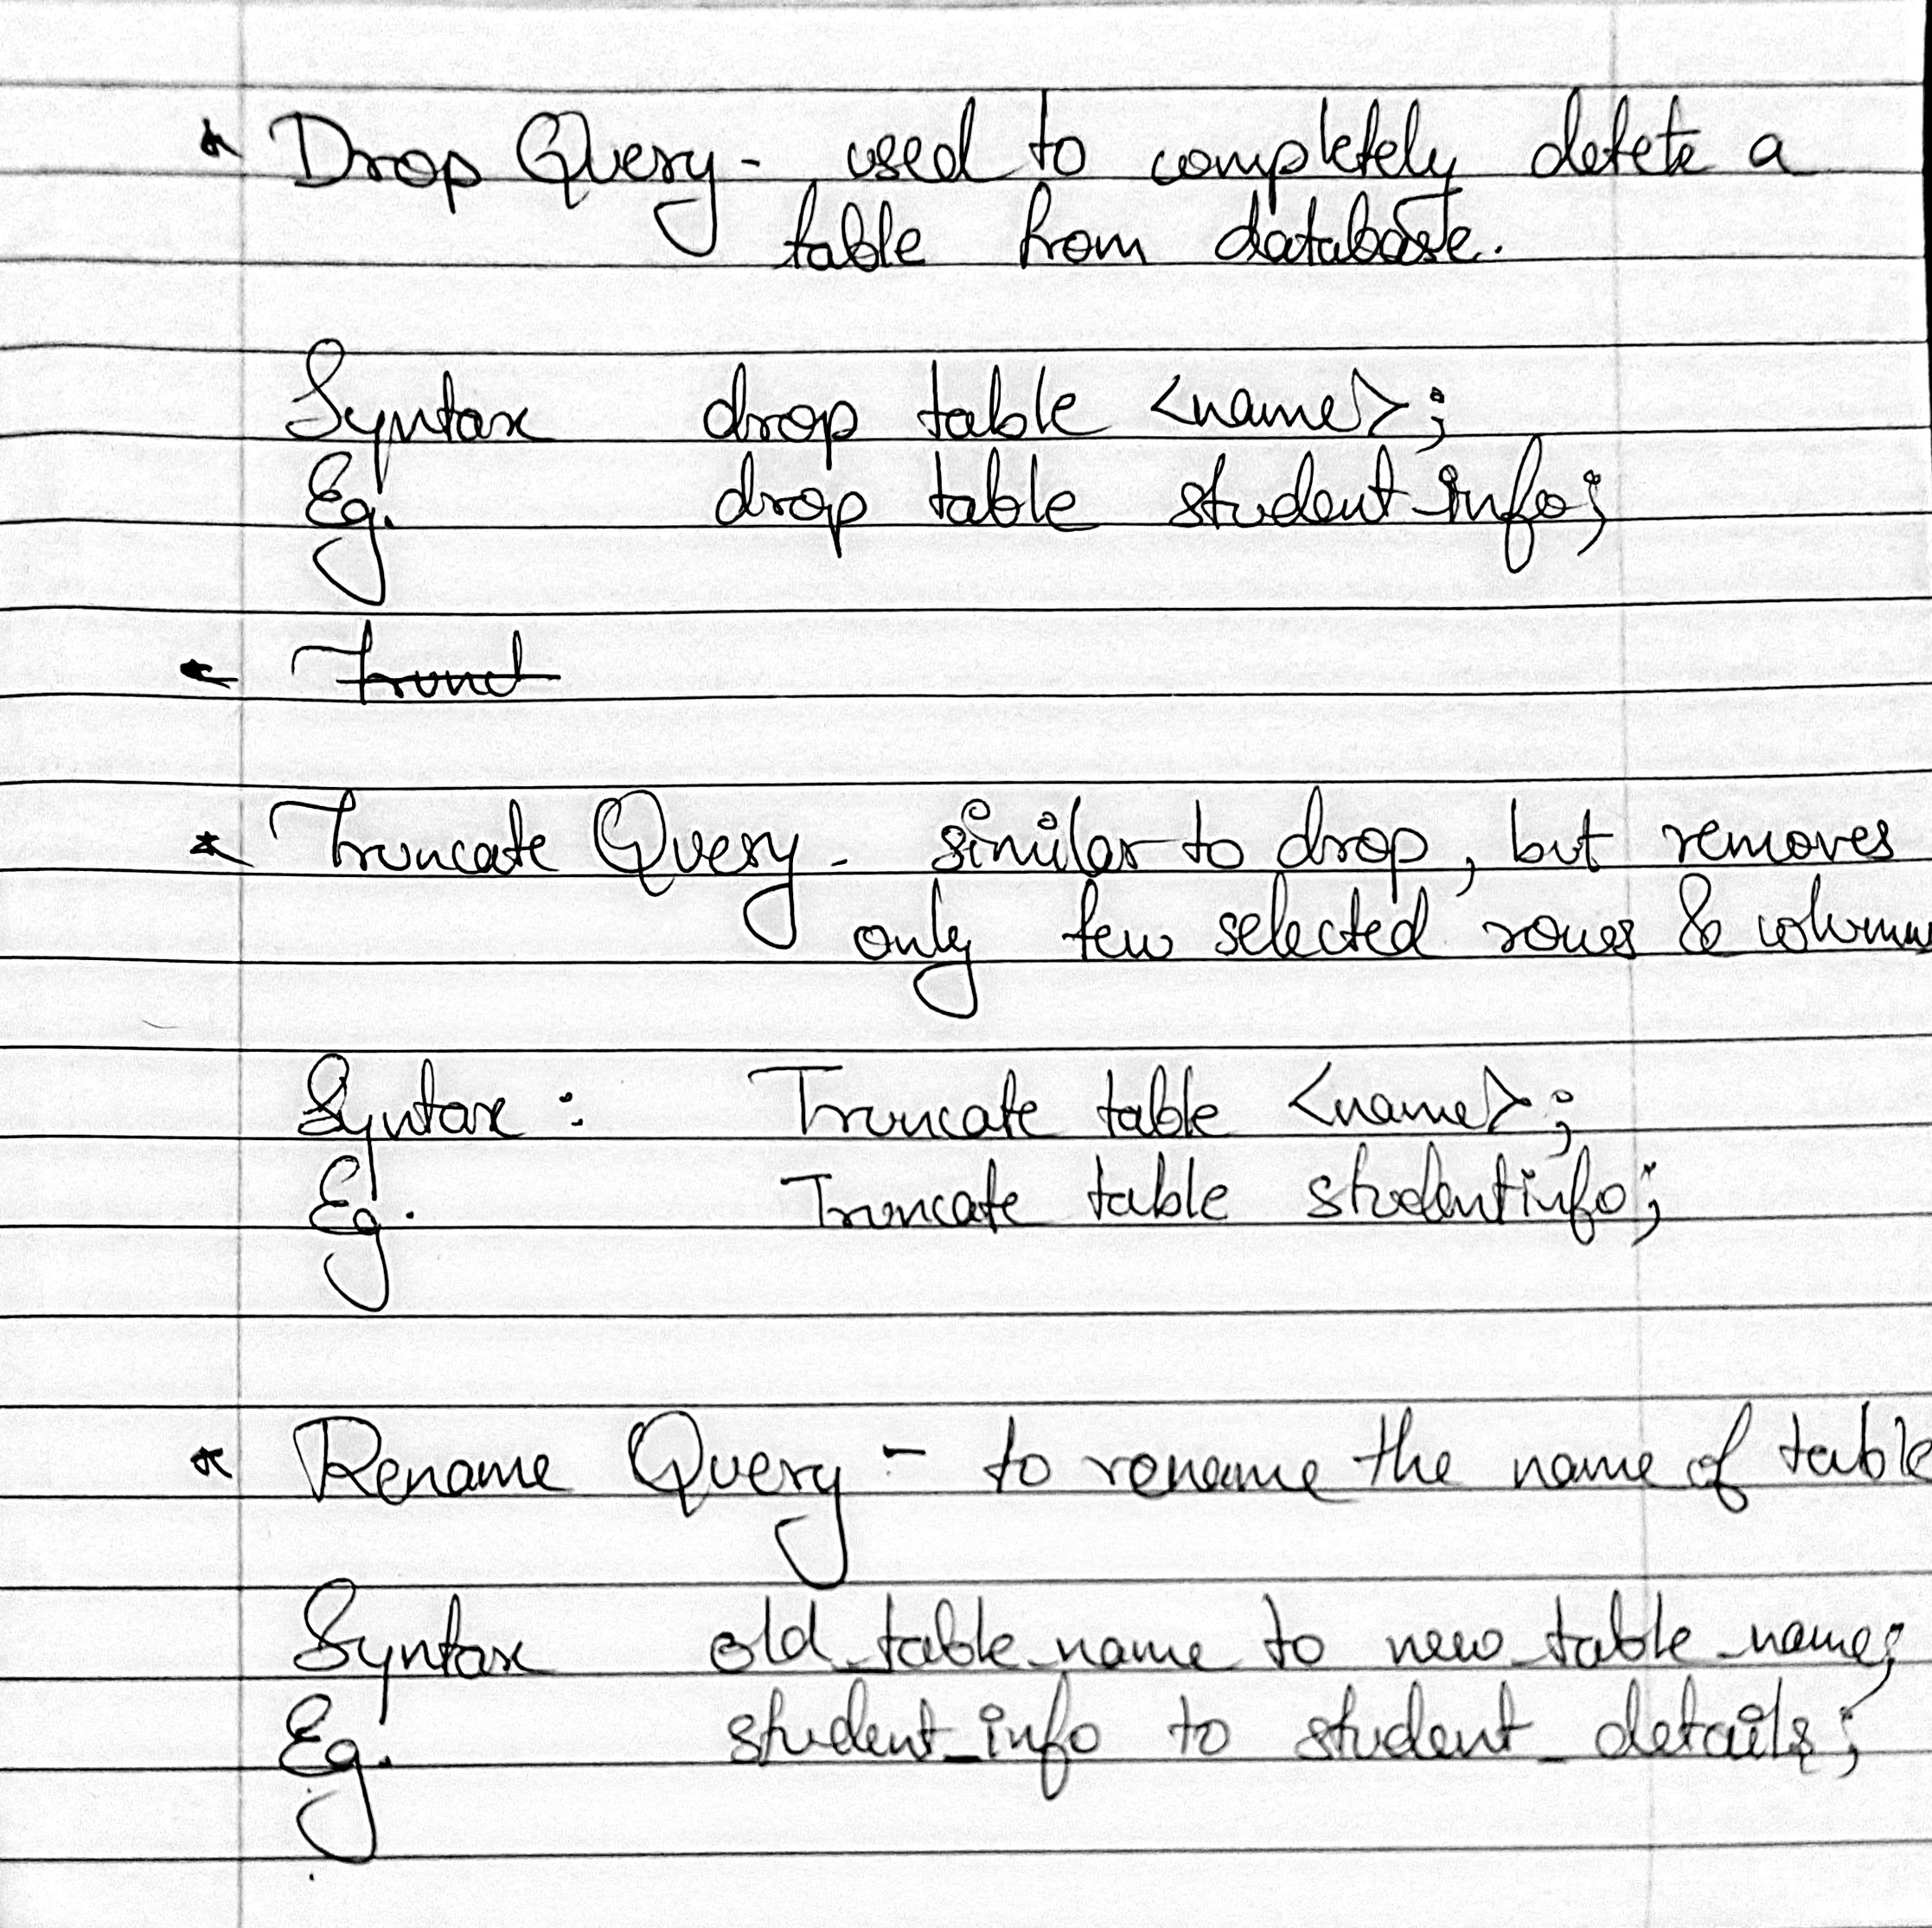

DDL Queries with Output:

1. Customer Table:

a. create table customer (cid int, cname varchar (20),address char(10));

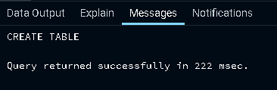

b. alter table customer add phno numeric (10);

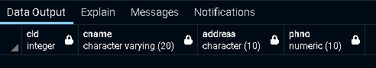

c. alter table customer modify address varchar (20);

alter table customer alter column address type varchar;



d. alter table customer drop column address;



2. Employee Table

a. create table employee (ssn int primary key, ename varchar(20) not null, salary int,dno int,Foreign key(dno) references dept(dno));



b. alter table employee add constraint fk_dno foreign key(dno) references dept1(dno);

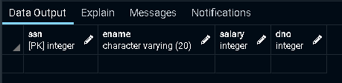

3. Department Table:

a. create table dept1(dno int primary key,dname varchar(20),mgrssn int references employee,startdate datetime);

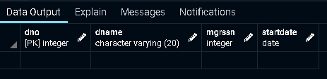

4. Deptlocation Table:

a. create table deptloc(dno int,dloc varchar(20),primary key(dno,dloc),foreign key(dno) references dept1(dno));

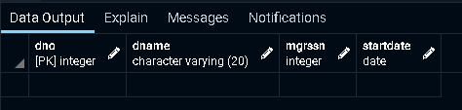

5. Project Table:

a. create table project (pno int primary key,pname varchar(20),dno int references dept1(dno));

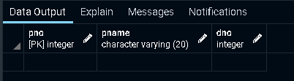

6. Table Dependent:

a. create table dependent(ssn int,depname varchar(20),relation varchar(20), primary key(ssn,depname),foreign key(ssn) references employee(ssn));



